Flipkart project with MYSQL database

1. Create flipkart project , Create 2 applications : product and user and open project in vs code

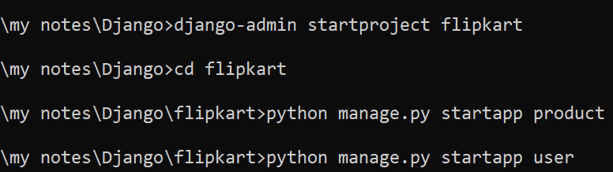

1. Register applications in settings.py

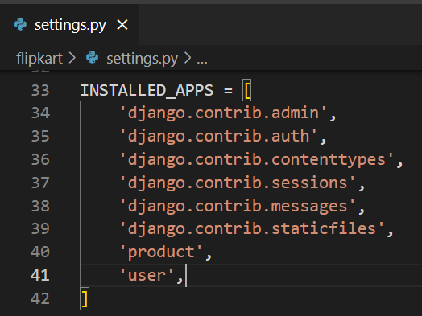

1. Working with mysql database
   1. Be ready with database name, username and password
      1. Here I am using default username and password of mysql i.e root and root
   2. Create new database for our project in workbench

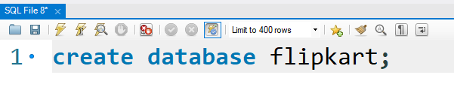

* 1. In setting.py register above database with user credentials

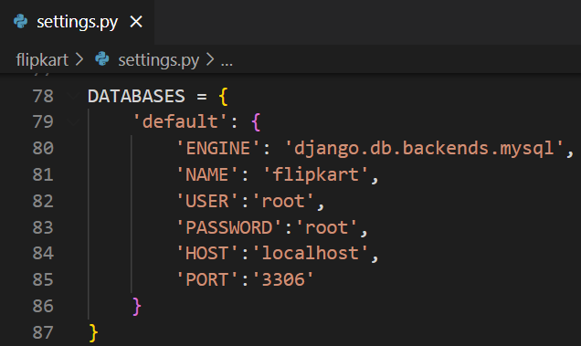

*VERY IMPORTANT: PLEASE CHECK YOUR PORT NUMBER IN WORKBENCH*

* 1. Install mysqlclient library

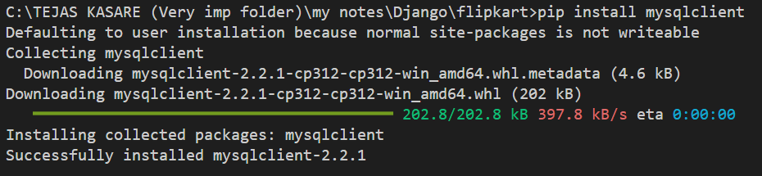

* 1. Runserver : open terminal in vs code and run : >python manage.py runserver
  2. Open new terminal on vs code and check for django to mysql connetion by running following command

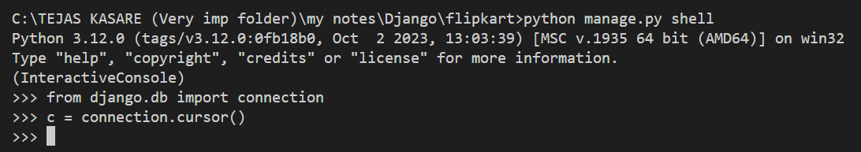

1. Create model class in models.py

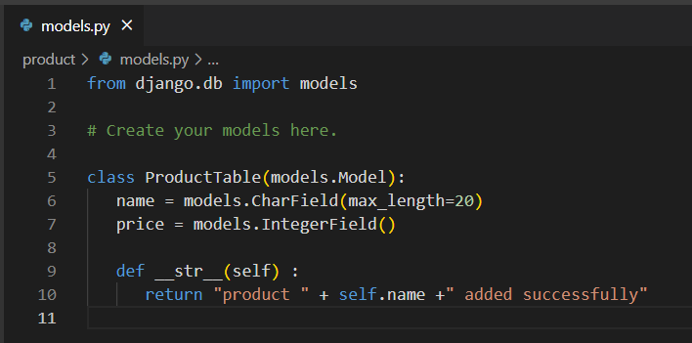

1. Register model class in admin.py

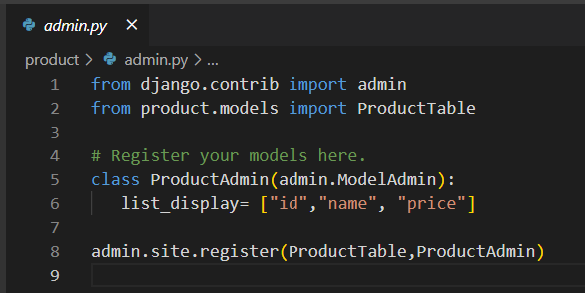

1. Makemigrations and migrate

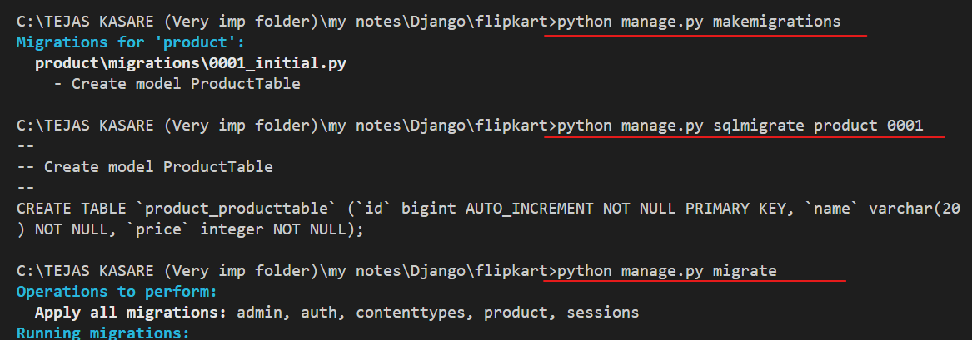

1. check tables in flipkart database

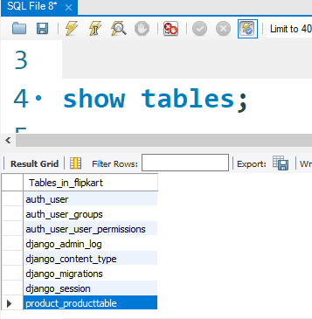

1. View structure of product_producttable table

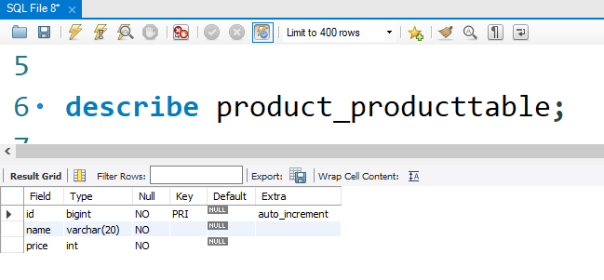

1. DONE !!!!!!!!!!!!!!!
2. Creating superuser to access admin panel

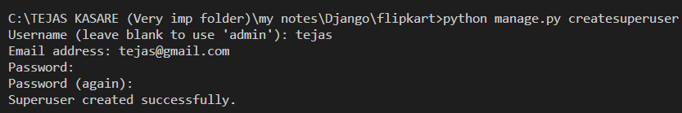

tejas, admin@123

1. Open admin panel by : <http://127.0.0.1:8000/admin> and add above credentials
2. You will get product table

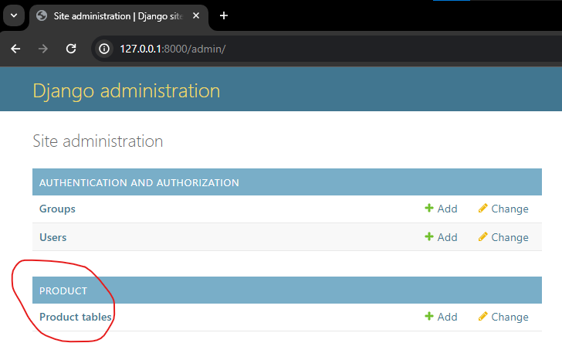

1. Add some data in product table

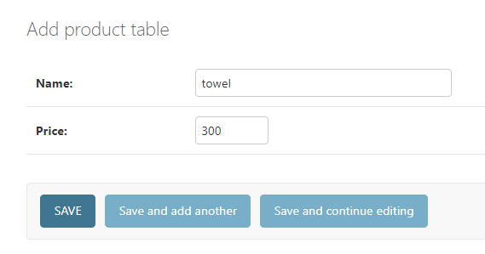

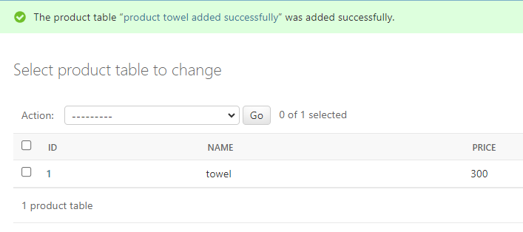

1. Check in mysql

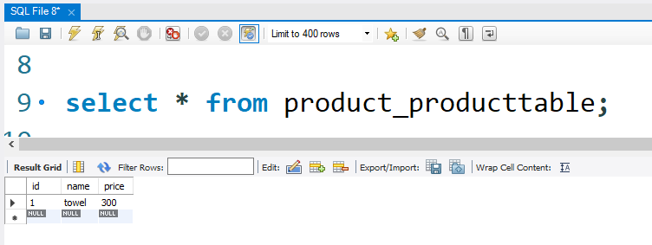

1. DONE !!!!!!!!!!!!!!!!!